Exercise 1

Photograph

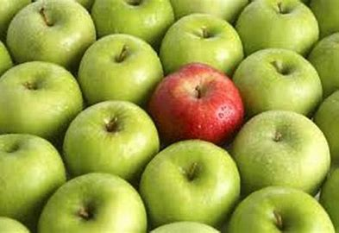This photo shows all three dominance, subordination, and contrast. The red apple is the focal point and all the green apples are less important. The green and red are two contrast colors.

Graphic design

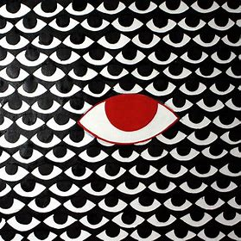This graphic design shows dominance and subordination. The red eye is the focal point and stands out.

Painting

This painting has all three. The red is the focal point and the trees blur in. with subordination and the contrast of the values.

Sculpture

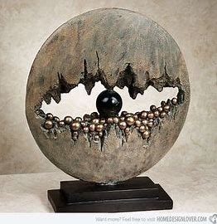 This sculpture has dominance with the black ball in the middle. There is contrast with the hole around the black ball.

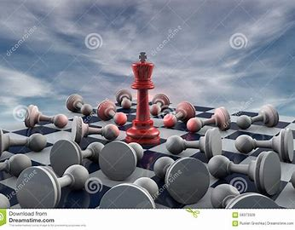 This illustration has dominance and subordination. With the one standing in the middle in red with the most saturation it draws the eye.